North Ayrshire Educational Psychology Neurodiversity Modules Overview
Scottish legislation and policy support inclusion and the raising of attainment for all. Education teams work hard every day to support the needs of all learners and have expertise in supporting the additional support needs of neurodivergent learners. As we all continue to learn more about effective supports, teams can benefit from access to high quality professional learning and coaching to further develop skills. | 
The following modules have been created to develop practitioners’ expertise and confidence when working with neurodivergent learners. It is recommended that teams and/or practitioners begin with Modules 1.1 and 1.2, thereafter working through modules according to professional learning needs. Here is an overview of each module – further detail available in the appendix. | 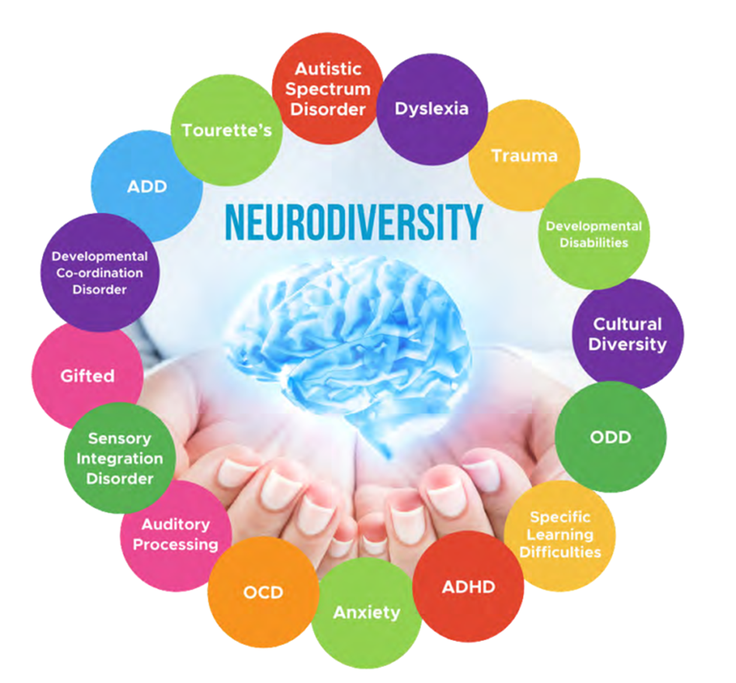

1.1 Introduction to Neurodiversity | Overview of Neurodiversity, relevant policy and legislation that supports inclusion and all 7 modules.
1.2 Effective & Inclusive Learning and Teaching Approaches | Supports practitioners to further develop knowledge and understanding of inclusive learning and teaching approaches that support all learners, including those with neurodivergent learning profiles.
2. Communication & Language | Supports practitioners to understand and support different communication and language needs, including information about Communication Friendly Environments, AAC, visual communication supports and the SCERTS framework.
3. Social & Emotional Needs | Supports further understanding of different social and emotional needs and approaches that support learners to understand and navigate social situations in an education setting.
4. Cognition | 4.1 - Explores how our memories work so that practitioners can develop a shared understanding of how learners retain new information in the short term and over time.  4.2 - Focuses on Executive Functioning skills and how they develop and impact on our daily interactions and everyday activities.
5. Environmental & Sensory Needs | Explores differences in sensory experiences and sensory regulation needs. Supports practitioners to understand and reduce sensory demands, by adapting environments and introducing sensory regulating activities for learners.
6. Motor Skills & Co-ordination | Provides an insight into motor differences and co-ordination difficulties and some ways that learners’ motor needs and differences can be supported in education.
7. Stress & Anxiety | Acknowledging the cross-over between Neurodivergent experiences and wellbeing needs, this module provides an overview of stress and anxiety and explores some of the ways stress and anxiety may impact learners who are Neurodivergent.  Introduces practitioners to some of the ways we can reduce stress and anxiety in education settings and support learners with stress and anxiety management.

Appendix – Additional Neurodiversity Module information

Module 1 – Introduction to Neurodiversity

This module provides an overview of all 7 modules and information around relevant policy and legislation that supports inclusion.

Module contents:

- Definition of neurodiversity and key related terms
- An overview of national legislation and local policy that underpins inclusive practice
- An overview of the Neurodiversity modules, aims and content

Module 1.2 – Effective and Inclusive Learning and Teaching Approaches

This module supports practitioners to further develop knowledge and understanding of inclusive learning and teaching approaches that support all learners, including those with neurodivergent learning profiles.

Module contents:

- Creating a supportive and positive learning environment for all
- Building an ongoing, understanding of learners and their needs
- Ensuring high quality teaching
- Complementing high quality teaching with carefully selected small group and individual interventions
- Working effectively with classroom assistants

Module 2 – Communication and Language
This module aims to support practitioners to understand and support different communication and language needs, including information about Communication Friendly Environments, AAC, visual communication supports and the SCERTS framework.
Module contents:
- What is communication?
- Effective practice to support communication
- Visual supports
- Use of Augmentative and alternate communication (AAC)
- Use of ICT to support communication
- Introduction to specific approaches to supporting communication e.g. Elklan, PECS, Talking Mats

Module 3 – Social and Emotional Needs

This module supports practitioners to further develop understanding of the unmet needs behind inappropriate or inconvenient behaviours and approaches that support learners to successfully navigate social situations in an education setting.

Module contents:

- The needs behind behaviour
- The Hidden Curriculum – definition and impact on neurodivergent learners
- How to adapt the physical and social environment to support
- How to develop learner skills so they can thrive socially and emotionally in school

Module 4 - Cognition
4.1– Working Memory

This module explores how our memories work so that practitioners can develop a shared understanding of how learners retain new learning in the short term and over time. It also investigates a range of strategies and interventions that support effective recall, and ways in which practitioners can develop a memory friendly learning environment.

Module contents:

- How does memory work?
- What is Working Memory?
- Supporting memory effectively in the classroom to secure learning
- What is metacognition and cognitive load and how can we use them effectively to support and retain learning?

Module 4: Cognition
4.2 – Executive Functioning

This module follows on from Cognition Part 1, and focuses on Executive Functioning Skills and how they develop and impact on our daily interactions and everyday activities.

Module contents:

- Understanding the term Executive Functions/Executive Functioning and why these matter
- Exploring the development of Executive Functions in relation to how the brain learns and develops
- Explore the components of Executive Functions (planning, impulse control, working memory and others)
- Understanding how differences and difficulties with Executive Function skills can affect access to the curriculum as well as everyday life skills
- Consideration of the spectrum of Executive Function skills and the range of learners who may have difficulties with Executive Function skills.

Module 5 – Environmental and sensory

This module aims to cover how learners differ in their sensory needs. This supports an awareness of how we can adapt our education environments to better understand the impact of, and reduce sensory demands to allow our learners to achieve their potential.

Module contents:

- What are the senses?
- What is sensory processing?
- How to explore sensory behaviours and what strategies to use to support learners with sensory differences
- Structured teaching – what this is and how to implement

Module 6 – Motor Skills and Co-ordination

This module aims to provide a deeper understanding of motor differences across our learners and how we can best support neurodiversgence in our classrooms and schools.

Module contents:

- What are motor skills?
- What mobility differences are there?
- How to support mobility in EY
- How to support mobility in Primary
- How to support mobility in Secondary
- handwriting
- Each section covers stage appropriate strategies for fine motor skills and gross motor skills.
- How practitioners can explore motor development needs and apply strategies to support learners.

Module 7 – Supporting Stress and Anxiety

This module acknowledges the cross-over between Neurodivergent experiences and wellbeing needs, providing an overview of stress and anxiety and exploring some of the ways stress and anxiety may impact learners who are Neurodivergent.
Module contents:

- Exploring the basics of anxiety – signs and symptoms
- Exploring how anxiety may be experienced and brought about for learners
- Identifying factors of anxiety during the global pandemic (some of the expectations / pressures around behaviour under the “new normal”)
- Consideration of a number of different approaches and strategies for supporting learners displaying or expressing anxiety
- Building resilience and learning new strategies to best support anxiety and preparation to help and support learners

COLLABORATION TRANSPARENCY IMPACT

