
A Whole School Wellbeing Approach:
Using Pupil Attitudes to Self and School –Targeted Interventions and Impact
North Ayrshire Council Educational Psychology Service

Introduction
High quality learning and teaching is underpinned by an ethos of promoting positive health and wellbeing for the development of every child. North Ayrshire – at authority and school level - has a clear vision to ensure the needs of children and young people are being met, ensuring their experience in education helps them fulfil their maximum potential. North Ayrshire’s Health and Wellbeing strategy focuses on the importance of a whole school approach in implementing effective evidence-based interventions and tracking this progress at authority and national level. Current authority arrangements include using the Pupil Attitude to Self and School. Future arrangements will include using the new national HWB census, being developed as part of the NIF.
North Ayrshire Council issued a recent survey to all schools, to consider and inform the use of PASS in the context of their school. Thus, highlighting its role in implementation of targeted interventions at individual, group and whole school levels in addressing the interrelating factors of pupil wellbeing and attainment.

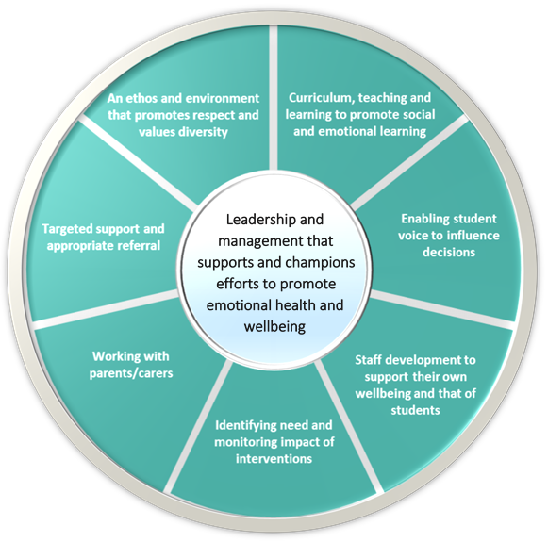

Whole School Approach to Wellbeing
In planning to maximise the health and wellbeing of North Ayrshire’s children and young people:
- Health and wellbeing must be fully embedded in all aspects of the school environment. This should reinforce a strengths based approach to promote inclusion, improve attainment and reduce inequalities (Humphrey 2017).
- There needs to be recognition that positive relationship approaches underpin a better learning experience.
- Through use of effective assessment and wellbeing measures, identifying difficulties allows for early implementation of targeted interventions.

Effective Implementation of Wellbeing Interventions
Effective implementation is an essential element to our whole school approach to wellbeing. Even evidence based Interventions can only be effective if they are implemented well. To support this process, consideration must be given to the potential contextual factors which must be in place for maximising success, possible barriers which may hinder progression and how the intended impact will be evidenced.
For further guidance on the process of effective implementation and applicable tools to support staff which are relevant to existing and future planned interventions, please contact the Educational Psychological Service.

Effectiveness of Pupil Attitudes in improving attainment:
Pupil Attitudes to Self and School (PASS) is an attitudinal survey which provides measurement of a pupil’s attitudes towards themselves as learners and their attitudes towards school and has been utilised as a measure in planning and evaluating interventions. Representatives from North Ayrshire Schools have reported through the use of PASS they have been able to:
- Enhance the schools’ ability to identify and respond effectively to wellbeing needs.
- Capture children’s self-regard and confidence as learners. This links pupil motivation to achievement and self-worth (Csikszentmihalyi & Rathunde’s 1993).
- Reaffirm what is already working and areas which could be looked at to improve pupil satisfaction.
- Provide measurement of short and long term impact by establishing baselines to use for yearly comparisons.
- Promote collaborative working between pupils, parents and the wider community ensuring continuity in knowledge and skills.
- Indicate additional specified measures for wellbeing, dependent on support which has been developed.
- Promote a whole school wellbeing approach. Targeted interventions developed from the factors of PASS sit within already existing initiatives – including nurture and attachment - essential to positive wellbeing.
PASS, as well as additional tools can be used in effective implementation of targeted interventions. Standardised measures for health and wellbeing are essential for evidencing progression in experience and outcomes for children and young people. The following examples of impact measurements below are not an exhaustive list but could also be used for further targeted interventions following the initial use of PASS:
- The Boxall Profile (Suitable for ages 4-18)
- Warwick-Edinburgh Mental Wellbeing Scale (WEMWBS) (Suitable for ages 13-18)
- Stirling Children’s Wellbeing Scale (SCWBS) (Suitable for ages 8-15)
- Strength and Difficulties Questionnaire (SDQ) (Suitable for ages 4-16)

PASS
Page 2



The Nine PASS Factors – Next Steps for Intervention
In looking at the results of PASS, the measures relate to key themes of wellbeing within factors of education. The PASS report can guide practitioners in reaffirming and challenging expectations within cohorts and individuals’ school experiences.
The Nine PASS Factors – Steps for Support resource has been developed to provide further guidance with targeted interventions which;

- Incorporate a whole school approach to wellbeing.
- Reinforce the vision set by North Ayrshire’s Health and Wellbeing Strategy and the Curriculum for Excellence.

- https://www.gl-assessment.co.uk/media/294651/childrenswellbeingreport2018.pdf
- North Ayrshire Council – Health and Wellbeing Strategy (2017-2022)
- https://www.gl-assessment.co.uk/PASS
- Education Scotland National Improvement Hub – EEF and Implementation Science Guidance.
- https://www.gov.uk/government/publications/promoting-children-and-young-peoples-emotional-health-and-wellbeing

Sources and Recommended Reading

Want to find out more?
Talk to NAC Educational Psychological Service if you would like further information regarding:
- The use of PASS or advice to support effective implementation of interventions identified by PASS results.
- Impact measures for interventions identified in in this spotlight (or information on further examples).
- Next steps in relation to NAC Health and Wellbeing strategy (in collaboration with the PT for health and wellbeing)

