Restorative Approaches

Positive relationships in education are key to effective learning, teaching and health and wellbeing (M. Thorsborne). Restorative approaches are fundamentally grounded in repairing and resorting relationships when they have been harmed. It moves away from the language and culture of restorative justice towards an ethos of relational problem solving for the repair of harm. It is a philosophy, not a model, and ought to guide the way we act in our dealings with others (B. Hopkins).
Training
So far all clusters have been represented on 2 ½ day training coursed with senior managers in schools making moves to embed the approach across their establishments. Training continues across the authority and is needs led. So far a number of clusters have requested abridged training for staff as part of their own improvement framework of training relating to Promoting Positive Relationships. Consideration is being given to how best to involve parents and pupils in the roll out.

Current Goals
By July 2017-
- All schools will have had SMT represented on the 2.5 day training
- All schools will be implementing positive relationships initiatives as part of their improvement plan. Of those concentrating on RA. Restorative approaches will be evident in their policies
- Psychological services will continue to support the roll out via call back and facilitating network sessions
- Impact evaluation collation using EVA, insight and pre-training data.

By July 2018-
- The first NAC restorative conference with contributions of good practice being shared. Watch this space!
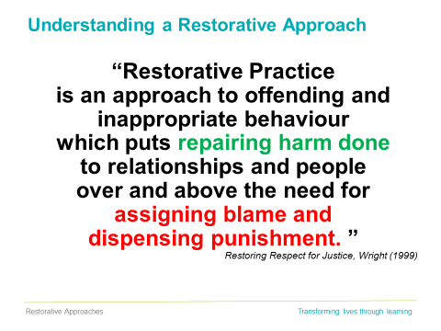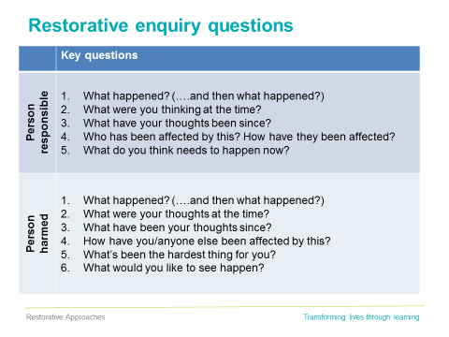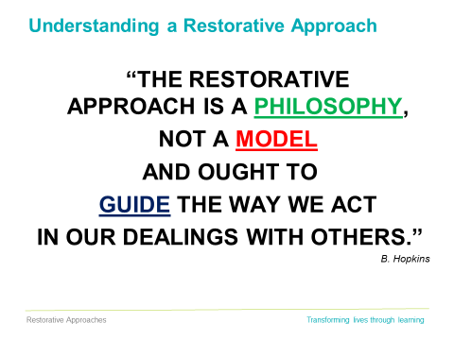
For more information contact:
smacleod@north-ayrshire.gcsx.gov.uk
tmoir@north-ayrhsire.gcsx.gov.uk

